**Tracking and curbing Black Money Using Big Data**

# Team Members

1. Akshay Nakhawa
2. Pranay Sampat
3. Ruchi Goyal
4. Maansi Chandira
5. Priyanka Bandekar

# Proposed Idea

The purpose of our project is to build a prototype model to track and curb black money by uncovering hidden patterns and unknown correlations, leading to the discovery of meaningful trends using MapReduce.

# Objective

**Following are the objectives of the project**

* To predict from where the black money is coming from and possible locations where cash hoarding may take place
* Detect the prospective black money transaction and suspected Pan Card Nos.
* Predict the value of required dependent variable for any unseen test dataset.
* The results from our project will in turn will be helpful for Tax department and other government agencies to catch black money holders.

# Assumption

* Only cash transactions are considered at banking and ATM systems as most of the black money or unaccounted money exists only in cash.
* Every bank account is associated with Pan Number.
* Banking systems are enabled with Scanning and Recording of the Currency serial number involved in any withdrawal/deposit transactions.
* Every transaction will record the associated Pan number and currency serial No
* Threshold is minimum of 5 lac for the transactions to be scrutinized.

# Data Definitions

**Blacklisted Notes**: Serial No of the notes which did not appear in any transaction in our system from more than three months

**PAN Number**: Unique identifier [Like SSN] associated with single person across multiple accounts.

**Location**: Geo locations where transactions originated, may or may not be different than PAN – home location.

**Threshold**: A minimum amount of 5 lacs for the transaction to be scrutinized.

# Use Case 1: Detecting Transactions with more than 70% BlackListed currency Serials

* 1. Process all the transaction and the associated currency no’s and detecting if the deposited transaction has more than 70% of blacklisted notes are involved that transaction.
  2. Deriving a relationship between the Depositor and last known Withdrawers of those BlackListed Notes involved in such transaction along with their corresponding locations.

# Approach

### Data Constraints

* Financial Records are not available publically.
* Currency Data with black listed currency holders was not available

### Data Processing

* Generating black listed currency data, from official currency table based on time stamp.
* Designing black listed currency with PAN number and location of the person/party involved in cash hoarding.
* Generating transactions data where in cash hoarding serial numbers are being deposited and are above than threshold.

BlackListed file



Transaction File: Which involved black listed serial number.

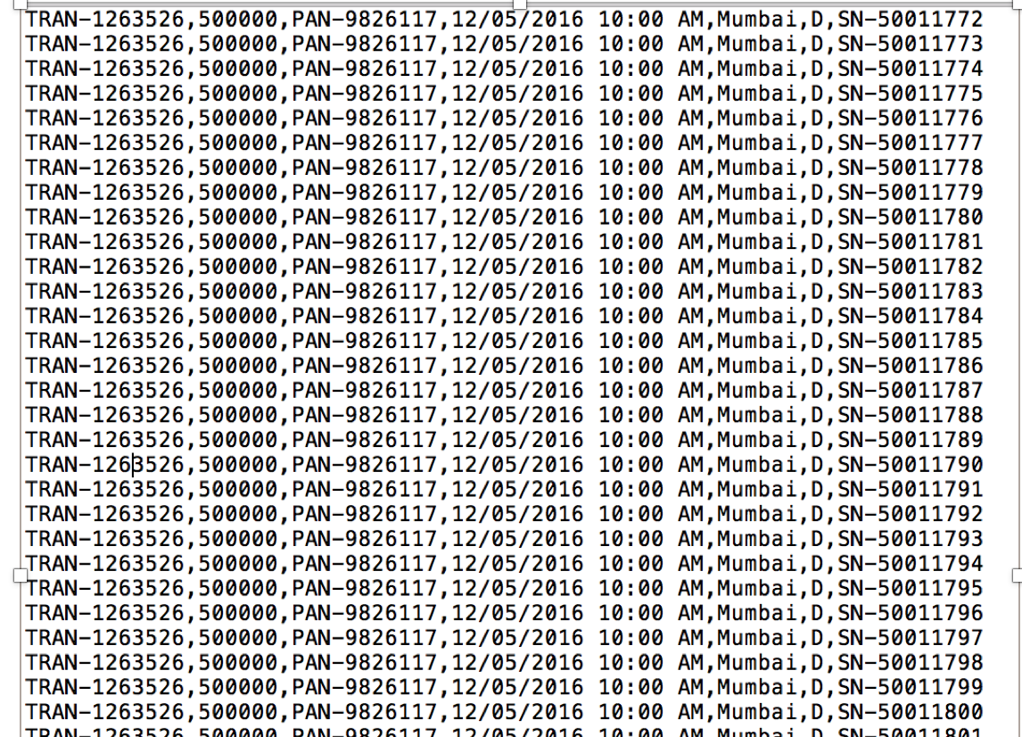

### Map- Reduce

**Map Reduce for Use Case 1:**

Inputs:

1. Blacklisted Currency File

Format – serial Number, blacklisting time Stamp, last Withdrawer Pan, last withdrawal Location

Eg : SN-50011172,1/3/2016 12:00 PM,PAN-9773780,Ludhiana

1. Transactions File

Format: Transaction ID, Amount, PAN, Time Stamp, Location, Type(W/D), currency Serial Number

Eg. TRAN-1263526, 500000,PAN-9826117,12/05/2016 10:00 AM,Mumbai,D,SN-50011772

Running instructions:

* The whole use case is run by a single driver. In project anti black money (org.abm.mapReduce1.Driver1) to be run with 5 arguments
* Two input files are blackmoney and transactions text file followed by 3 output files

**MapReduce Job 1: Processing both input files to get a combined key value pairs**

**Driver:** Job1 : used MultipleInputs in order to have 2 Mappers and one reducer

**Mapper1:**

Objective: Breaking black listed currency file into key value pairs

**Input –**

Serial Number, blacklisting time Stamp, last Withdrawer Pan, last withdrawal Location

**Output**

**Key** –serial Number **Value** - blacklisting time Stamp, last Withdrawer Pan, last withdrawal Location

SN-50011172,1/3/2016 12:00 PM,PAN-9773780,Ludhiana

SN-50011173,1/3/2016 12:00 PM,PAN-9773780,Ludhiana

SN-50011174,1/3/2016 12:00 PM,PAN-9773780,Ludhiana

SN-50011175,1/3/2016 12:00 PM,PAN-9773780,Ludhiana

SN-50011176,1/3/2016 12:00 PM,PAN-9773780,Ludhiana

SN-50011172 1/3/2016 12:00 PM,PAN-9773780,Ludhiana

SN-50011173 1/3/2016 12:00 PM,PAN-9773780,Ludhiana

SN-50011174 1/3/2016 12:00 PM,PAN-9773780,Ludhiana

SN-50011175 1/3/2016 12:00 PM,PAN-9773780,Ludhiana

SN-50011176 1/3/2016 12:00 PM,PAN-9773780,Ludhiana

**Mapper2:**

Objective: Breaking transaction file into key value pairs according to serial Number (only for transactions above 500,000 INR)

**Input –**

Transaction ID, Amount, PAN, Time Stamp, Location, Type, currency Serial Number

**Output**

**Key** –serial Number **Value** - Transaction ID, Amount, PAN, Time Stamp, Location, Type(W/D)

TRAN-1263526,500000,PAN-9826117,12/05/2016 10:00 AM,Mumbai,D,SN-50011772

TRAN-1263526,500000,PAN-9826117,12/05/2016 10:00 AM,Mumbai,D,SN-50011773

TRAN-1263526,500000,PAN-9826117,12/05/2016 10:00 AM,Mumbai,D,SN-50011774

TRAN-1263526,500000,PAN-9826117,12/05/2016 10:00 AM,Mumbai,D,SN-50011775

TRAN-1263526,500000,PAN-9826117,12/05/2016 10:00 AM,Mumbai,D,SN-50011776

SN-50011772 TRAN-1263526,500000,PAN-9826117,12/05/2016 10:00 AM,Mumbai,D

SN-50011773 TRAN-1263526,500000,PAN-9826117,12/05/2016 10:00 AM,Mumbai,D

SN-50011774 TRAN-1263526,500000,PAN-9826117,12/05/2016 10:00 AM,Mumbai,D

SN-50011774 TRAN-1263526,500000,PAN-9826117,12/05/2016 10:00 AM,Mumbai,D

SN-50011774 TRAN-1263526,500000,PAN-9826117,12/05/2016 10:00 AM,Mumbai,D

**Reducer 1:**

**Objective : Get input from both Mappers and for the currency serials from blacklisted file, append the blacklisting details to the input from the transaction file mapper.**

**Input :**

**Key** –serial Number **Value** - Transaction ID, Amount, PAN, Time Stamp, Location, Type(W/D)

**OR/AND**

**Key** –serial Number **Value** - blacklisting time Stamp, last Withdrawer Pan, last withdrawal Location

**Output**

**Key** –serial Number **Value** - Transaction ID, Amount, PAN, Time Stamp, Location, Type(W/D),(may or may not have) blacklisting time Stamp, last Withdrawer Pan, last withdrawal Location

SN-50011172 1/3/2016 12:00 PM,PAN-9773780,Ludhiana

SN-50011772 TRAN-1263526,500000,PAN-9826117,12/05/2016 10:00 AM,Mumbai,D

SN-50011772 TRAN-1263524,600000,PAN-9826119,12/05/2015 10:00 AM,Ludihiana,W

SN-50011772 TRAN-1264526,500000,PAN-9826127,02/05/2016 10:00 AM,Panjim,D

SN-50011772 TRAN-1266626,505000,PAN-2226117,12/06/2016 10:00 AM,Bhatinda,W

Note: since the input from 2 mappers may reach one reducer, the input will be of variable length.

But since, serial Numbers is made the key.

If the value from blacklisted mapper is present (i.e. if note is blacklisted)

Append blacklisting details to the input from transactions mapper

SN-50011172 1/3/2016 12:00 PM,PAN-9773780,Ludhiana

SN-50011772 TRAN-1263526,500000,PAN-9826117,12/05/2016 10:00 AM,Mumbai,D

SN-50011772 TRAN-1263524,600000,PAN-9826119,12/05/2015 10:00 AM,Ludihiana,W

SN-50011772 TRAN-1264526,500000,PAN-9826127,02/05/2016 10:00 AM,Panjim,D

SN-50011772 TRAN-1266626,505000,PAN-2226117,12/06/2016 10:00 AM,Bhatinda,W

SN-50011772 TRAN-1263526,500000,PAN-9826117,12/05/2016 10:00 AM,Mumbai,D, 1/3/2016 12:00 PM,PAN- 9773780,Ludhiana

SN-50011772 TRAN-1263524,600000,PAN-9826119,12/05/2015 10:00 AM,Ludihiana,W, 1/3/2016 12:00 PM,PAN-9773780,Ludhiana

SN-50011772 TRAN-1264526,500000,PAN-9826127,02/05/2016 10:00 AM,Panjim,D, 1/3/2016 12:00 PM,PAN-9773780,Ludhiana

SN-50011772 TRAN-1266626,505000,PAN-2226117,12/06/2016 10:00 AM,Bhatinda,W. 1/3/2016 12:00 PM,PAN-9773780,Ludhiana

If serial number is not a blacklisted note(Output as it is)

SN-50011772 TRAN-1263526,500000,PAN-9826117,12/05/2016 10:00 AM,Mumbai,D

SN-50011772 TRAN-1263524,600000,PAN-9826119,12/05/2015 10:00 AM,Ludihiana,W

SN-50011772 TRAN-1264526,500000,PAN-9826127,02/05/2016 10:00 AM,Panjim,D

SN-50011772 TRAN-1266626,505000,PAN-2226117,12/06/2016 10:00 AM,Bhatinda,W

**Overall Job1 Output:**

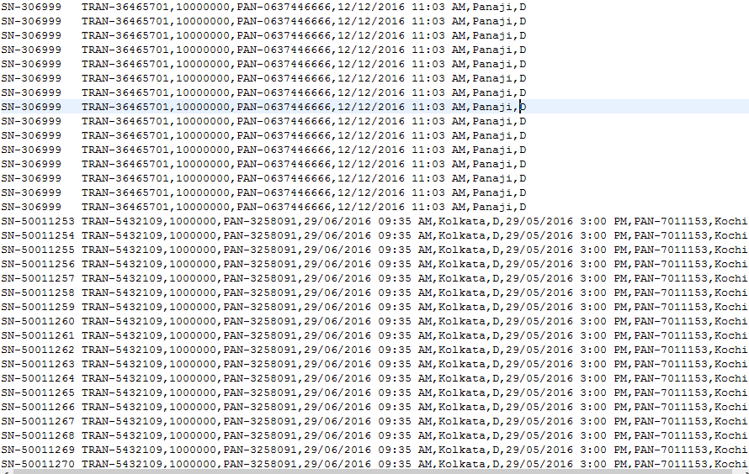

Black listed Notes

Nonblack listed Notes

Stage 2:

Objective:

If a transaction involves more than 70% of the blacklisted currency notes, derive a relationship between the depositor PAN and last known withdrawer of the blacklisted serials and their corresponding locations.

Mapper:

**Input (Output of previous stage)**

**Key** –serial Number **Value** - Transaction ID, Amount, PAN, Time Stamp, Location, Type(W/D),(may or may not have) blacklisting time Stamp, last Withdrawer Pan, last withdrawal Location

**Output**

**Key:** Transaction Id **Value:** serial Number, Amount, PAN, Time Stamp, Location, Type(W/D),(may or may not have) blacklisting time Stamp, last Withdrawer Pan, last withdrawal Location

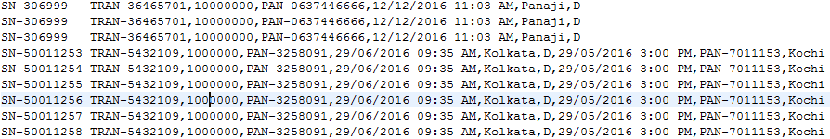

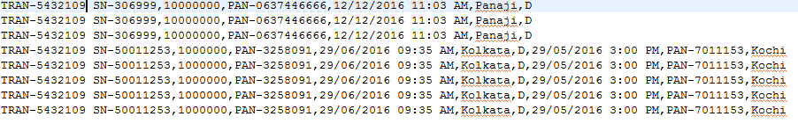

**Reducer**

**Input: Transactions and corresponding all the serial numbers (black listed or not)**

**Key:** Transaction Id **Value:** serial Number, Amount, PAN, Time Stamp, Location, Type(W/D),(may or may not have) blacklisting time Stamp, last Withdrawer Pan, last withdrawal Location

**Output:**

**Key:** Depositor PAN, Depositor **Location**

**Value:** transaction Id, amount, last Withdrawer PAN, last withdrawer Location



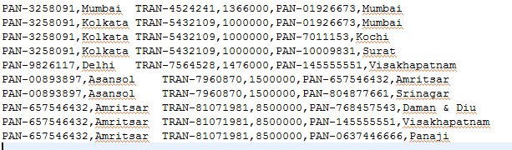

**Map Reduce 3:**

**Objective:**

Aggregate output from the stage 2 map reduce according to the PAN and find multiple relations between depositor PANs and Withdrawer PANs and their locations

**Input :**

**Key:** Depositor PAN, Depositor **Location**

**Value:** transaction Id, amount, last Withdrawer PAN, last withdrawer Location

**Output :**

**Key:** Depositor PAN, Depositor **Location**

**Value:** amount, last Withdrawer PAN, last withdrawer Location

**Reducer**

**Input :**

**Key:** Depositor PAN, Depositor **Location**

**Value:** amount, last Withdrawer PAN, last withdrawer Location

**Output:**

**Key-none**

**Value**- PAN,LOCATION, withdrawer PAN,LOCATION,AMOUNT

**FINAL OUTPUT**

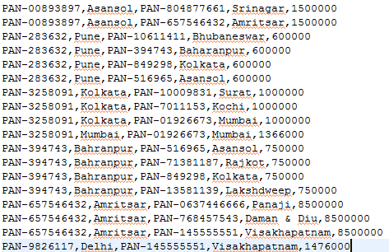

DepositorPAN Location LastWithdrawerPAN Location Amount

### Visualization

**Objective:**

Display the connections and locations of the transactions listed as Blackmoney Transactions.

**Approach:**

**Mapping the geo Location: (first map)**

The map is plotted in R and displayed using various libraries like maps, geosphere. In this map we are displaying the geographic locations and the connections between the two accounts involved in the fraudulent activity of money hoarding (transactions above 5 million and also above 70% of the total transactions notes which match the blacklisted notes.)

Obstacles:

Fetching the xlimit and ylimit of the map was an issue. As the transaction are located in India.

Resolved it by trial and error method and calculating the distance of extreme latitude and longitude of India.

**Network:** (second map)

The map is plotted in R and displayed using various libraries like igraph, network, sna, ndtv. In this map we are displaying the nodes as transaction account holders and edges as the link between the node. Every transaction is plotted on the graph and segregated using color. White transactions (No money hoarding) are given the color “Blue” whereas black transactions (transactions above 5 million and also above 70% of the total transactions notes which match the blacklisted notes) are given the color “Red”. The display is plotted on the browser. With additional features of displaying the ‘Pan Number and location’ on clicking the node and ‘Type of transaction (white or black) and amount’ on clicking the edges.

# Use Case 2: Detecting Probable Black Money Transaction

**Detecting if more than 70% of the serial notes in one transactions was a part of any withdrawal Transaction**

2.1 Withdrawal or deposit of an amount greater than 1 lac with more than 70% of notes that are **black listed notes.**

### Data Constraints

* To design data which can incorporate 70% of serial number in one deposit transaction which were involved in another withdrawal transaction.
* Designing data such that the time-stamp of deposit should be later than withdrawal [ which will always be the case in real-time.
* Generating transactions above the threshold.

### Data Processing

* Generating transactions data which involved serial number, PAN and GIO location.
* Designing transaction data which will involve 70 % of same serial number currency in deposit transaction that was previously involved in withdrawal transaction by some another PAN.
* Generating transactions data above than threshold

### Map- Reduce

**MapReduce Use Case2:**

Inputs:

1. Transaction File

Format – TransactionID, Amount, Pan, Timestamp, Location, Type, currencySerialNumber

Eg : TRAN-1263526,500000,PAN-9826117,12/05/2016 10:00 AM,Mumbai,D,SN-50011772a

Running instructions:

* The whole use case is run by a single driver. In project AntiBlackMoney 2.1 (org.abm.mapReduce1.Driver1) to be run with 4 arguments
* One input file Transactions followed by 3 output files

**MapReduce Job 1: Processing input file to get a combined key value pairs**

**Driver:** Job1: use one input file of WDTansactions having 1 Mappers and 1 reducer

**Mapper1:**

Objective: To make TransactionID as key and rest of the columns as Values

**Input –**

TransactionID, Amount, Pan, Timestamp, Location, Type, currencySerialNumber

**Output**

**Key** –TransactionID **Value** - Amount, Pan, Timestamp, Location, Type, currencySerialNumber

TRAN-0000001,1000000,PAN-9773700,29/06/2016 09:00 AM,Mumbai,W,SN-7001312

TRAN-0000001,1000000,PAN-9773700,29/06/2016 09:00 AM,Mumbai,W,SN-7001314

TRAN-0000001,1000000,PAN-9773700,29/06/2016 09:00 AM,Mumbai,W,SN-7001315

TRAN-0000001,1000000,PAN-9773700,29/06/2016 09:00 AM,Mumbai,W,SN-7001316

TRAN-0000001,1000000,PAN-9773700,29/06/2016 09:00 AM,Mumbai,W,SN-7001317

TRAN-0000001,1000000,PAN-9773700,29/06/2016 09:00 AM,Mumbai,W,SN-7001318

TRAN-0000001,1000000,PAN-9773700,29/06/2016 09:00 AM,Mumbai,W,SN-7001319

TRAN-0000001 1000000,PAN-9773700,29/06/2016 09:00 AM,Mumbai,W,SN-7001312

TRAN-0000001 1000000,PAN-9773700,29/06/2016 09:00 AM,Mumbai,W,SN-7001314

TRAN-0000001 1000000,PAN-9773700,29/06/2016 09:00 AM,Mumbai,W,SN-7001315

TRAN-0000001 1000000,PAN-9773700,29/06/2016 09:00 AM,Mumbai,W,SN-7001316

TRAN-0000001 1000000,PAN-9773700,29/06/2016 09:00 AM,Mumbai,W,SN-7001317

TRAN-0000001 1000000,PAN-9773700,29/06/2016 09:00 AM,Mumbai,W,SN-7001318

TRAN-0000001 1000000,PAN-9773700,29/06/2016 09:00 AM,Mumbai,W,SN-7001319

**Reducer 1:**

**Objective : Get input from Mapper, append the notesCount per transaction**

**Input :**

**Key** –TransactionID **Value** - TxnID,Amount,PAN,TimeStamp,Location,Type,currencySerialNumber

**Output**

**Key** – TransactionID **Value** -TxnID,Amount,PAN,TimeStamp,Location,Type,currencySerialNumber,notesCount

**Overall Job1 Output:**

TRAN-0000001 TRAN-0000001,1000000,PAN-9773700,29/06/2016 09:00 AM,Mumbai,W,SN-7001312,500

TRAN-0000001 TRAN-0000001,1000000,PAN-9773700,29/06/2016 09:00 AM,Mumbai,W,SN-7001314,500

TRAN-0000001 TRAN-0000001,1000000,PAN-9773700,29/06/2016 09:00 AM,Mumbai,W,SN-7001315,500

TRAN-0000001 TRAN-0000001,1000000,PAN-9773700,29/06/2016 09:00 AM,Mumbai,W,SN-7001316,500

TRAN-0000001 TRAN-0000001,1000000,PAN-9773700,29/06/2016 09:00 AM,Mumbai,W,SN-7001317,500

TRAN-0000001 TRAN-0000001,1000000,PAN-9773700,29/06/2016 09:00 AM,Mumbai,W,SN-7001318,500

TRAN-0000001 TRAN-0000001,1000000,PAN-9773700,29/06/2016 09:00 AM,Mumbai,W,SN-7001319,500

TRAN-0000001 TRAN-0000001,1000000,PAN-9773700,29/06/2016 09:00 AM,Mumbai,W,SN-7001320,500

TRAN-0000001 TRAN-0000001,1000000,PAN-9773700,29/06/2016 09:00 AM,Mumbai,W,SN-7001321,500

TRAN-0000001 TRAN-0000001,1000000,PAN-9773700,29/06/2016 09:00 AM,Mumbai,W,SN-7001322,500

TRAN-0000001 TRAN-0000001,1000000,PAN-9773700,29/06/2016 09:00 AM,Mumbai,W,SN-7001323,500

TRAN-0000001 TRAN-0000001,1000000,PAN-9773700,29/06/2016 09:00 AM,Mumbai,W,SN-7001324,500

TRAN-0000001 TRAN-0000001,1000000,PAN-9773700,29/06/2016 09:00 AM,Mumbai,W,SN-7001325,500

Stage 2:

Objective:

We consider only transactions having amount more than 500000 as it is set as a consideration for black money only. Here Serial number is made the key other columns as value

Mapper:

**Input (Output of previous stage)**

**Key** –TransactionID **Value** - TxnID,Amount,PAN,TimeStamp,Location,Type,currencySerialNumber,notesCount

**Output**

**Key:** Serial Number **Value:**  TxnID,Amount,PAN,TimeStamp,Location,Type,notesCount

TRAN-0000001 TRAN-0000001,1000000,PAN-9773700,29/06/2016 09:00 AM,Mumbai,W,SN-7001312,500

TRAN-0000001 TRAN-0000001,1000000,PAN-9773700,29/06/2016 09:00 AM,Mumbai,W,SN-7001314,500

TRAN-0000001 TRAN-0000001,1000000,PAN-9773700,29/06/2016 09:00 AM,Mumbai,W,SN-7001315,500

TRAN-0000001 TRAN-0000001,1000000,PAN-9773700,29/06/2016 09:00 AM,Mumbai,W,SN-7001316,500

TRAN-0000001 TRAN-0000001,1000000,PAN-9773700,29/06/2016 09:00 AM,Mumbai,W,SN-7001317,500

TRAN-0000001 TRAN-0000001,1000000,PAN-9773700,29/06/2016 09:00 AM,Mumbai,W,SN-7001318,500

TRAN-0000001 TRAN-0000001,1000000,PAN-9773700,29/06/2016 09:00 AM,Mumbai,W,SN-7001319,500

SN-7001312 TRAN-0000001,1000000,PAN-9773700,29/06/2016 09:00 AM,Mumbai,W,500

SN-7001312 TRAN-0000001,1000000,PAN-9773700,29/06/2016 09:00 AM,Mumbai,W,500

SN-7001315 TRAN-0000001,1000000,PAN-9773700,29/06/2016 09:00 AM,Mumbai,W,500

SN-7001316 TRAN-0000001,1000000,PAN-9773700,29/06/2016 09:00 AM,Mumbai,W,500

SN-7001317 TRAN-0000001,1000000,PAN-9773700,29/06/2016 09:00 AM,Mumbai,W,500

SN-7001318 TRAN-0000001,1000000,PAN-9773700,29/06/2016 09:00 AM,Mumbai,W,500

SN-7001319 TRAN-0000001,1000000,PAN-9773700,29/06/2016 09:00 AM,Mumbai,W,500

**Reducer**

**Input: Key- Serial Number Value: TxnID,Amount,PAN,TimeStamp,Location,Type,notesCount**

**Output:**

**To make transaction pairs and output deposit and withdraw type locations and PAN numbmers**

**Key:** Transaction Pairs

**Value: depAmount,depPAN,depTimeStamp,depLocation,notesCount,wPAN,wLocation**

**Final Output of Job2:**

TRAN-1215657:TRAN-5343809 950000,PAN-0284283,01/01/2016 02:01 PM,Mumbai,1900,PAN-1037217,Kolkata

TRAN-1215657:TRAN-5343809 950000,PAN-0284283,01/01/2016 02:01 PM,Mumbai,1900,PAN-1037217,Kolkata

TRAN-1215657:TRAN-5343809 950000,PAN-0284283,01/01/2016 02:01 PM,Mumbai,1900,PAN-1037217,Kolkata

TRAN-1215657:TRAN-5343809 950000,PAN-0284283,01/01/2016 02:01 PM,Mumbai,1900,PAN-1037217,Kolkata

TRAN-1215657:TRAN-5343809 950000,PAN-0284283,01/01/2016 02:01 PM,Mumbai,1900,PAN-1037217,Kolkata

TRAN-1215657:TRAN-5343809 950000,PAN-0284283,01/01/2016 02:01 PM,Mumbai,1900,PAN-1037217,Kolkata

TRAN-1215657:TRAN-5343809 950000,PAN-0284283,01/01/2016 02:01 PM,Mumbai,1900,PAN-1037217,Kolkata

TRAN-1215657:TRAN-5343809 950000,PAN-0284283,01/01/2016 02:01 PM,Mumbai,1900,PAN-1037217,Kolkata

TRAN-1215657:TRAN-5343809 950000,PAN-0284283,01/01/2016 02:01 PM,Mumbai,1900,PAN-1037217,Kolkata

TRAN-1215657:TRAN-5343809 950000,PAN-0284283,01/01/2016 02:01 sPM,Mumbai,1900,PAN-1037217,Kolkata

**Map Reduce 3:**

**Objective:**

To segregate Depositor PAN and withdrawer PAN with the count of serialnotes involved in that transaction pair.

**Reducer**

**Input :**

**Key:** Transaction PAIR

**Value:** depAmount,depPAN,depTimeStamp,depLocation,notesCount,wPAN,wLocationan

**Output:**

**Key- Depositor PAN, Location**

**Value**- Withdrawer PAN, Location,Count

**FINAL OUTPUT:**

PAN-001612032,Bhatinda,PAN-30673705,Delhi,550000

PAN-001612032,Bhatinda,PAN-849298,Kolkata,550000

PAN-001612032,Bhatinda,PAN-30673708,Guwahati,550000

PAN-001612032,Bhatinda,PAN-13581139,Lakshdweep,550000

### Visualization

Approach:

**Mapping the geo Location:** (first map)

The map is plotted in R and displayed using various libraries like maps, geosphere. In this map we are displaying the geographic locations and the connections between the two accounts involved in any transaction ( white money as well as black money).

**Network:** (second map)

The map is plotted in R and displayed using various libraries like igraph, network, sna, ndtv. In this map we are displaying the nodes as transaction account holders and edges as the link between the node. Every transaction is plotted on the graph and segregated using color. White transactions (No money hoarding) are given the color “Blue” whereas black transactions (transactions above 5 million and also above 70% of the total transactions notes which match the blacklisted notes) are given the color “Red”. The display is plotted on the browser. With additional features of displaying the ‘Pan Number and location’ on clicking the node and ‘Type of transaction (white or black) and amount’ on clicking the edges.

# Use Case 3: Page Rank

Use Case 3: Page Rank of the Suspected PANS

**Concept**

* Starting with multiple transactions having deposits and withdrawal’s
* Each withdrawal points to a deposit which in turn may point to a withdrawal in future
* Each withdrawal can point to multiple deposits (votes) likewise, each deposit can be a part of multiple withdrawals
* Every major depositor having highest score pointing to withdrawals becomes the in link (voters)
* Eventually, the depositor with maximum number of black money if points to another transaction, that transaction too comes under radar of having maximum count of black money

# The Page Rank value for a Depositor is dependent on the Page Rank value of each withdrawal out of the set of all withdrawals pointing to the same depositor.

# To map the analogy of a user starting at page and staying there is having the first depositor and last withdrawer having same PAN number.

# Algorithm for Map Reducing PageRank Iterator:

* **Begins with pair (Depositor, list-of-withdrawals)**

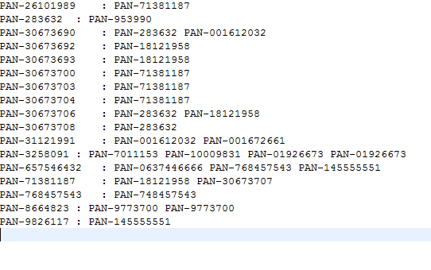

* **Transform to (Depositor, (PR, list-of-withdrawals)) After N Iterations:**

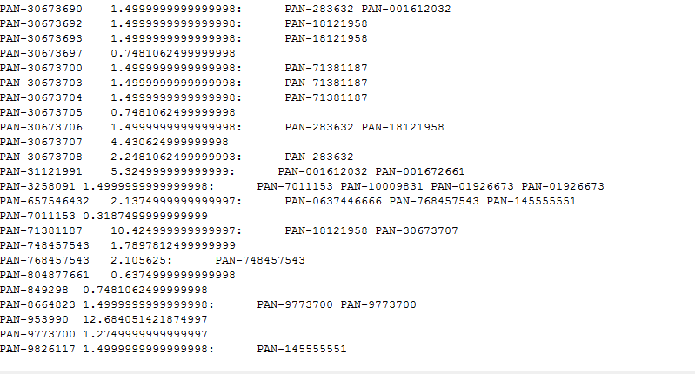

* **Map** for each withdrawal in list of withdrawals returns (Withdrawer, Depositor, PR(Depositor) / list-of-withdrawals. length ()), as well as (Depositor, list-of-withdrawals)
* **Reduce** receives (Depositor, list-of-Withdrawals), and many (Depositor, Value) pairs and calculates (Depositor, (new-PR, list-of-withdrawals))

**# PageRank Viewer Stage**

**Input : Iterator Input**

**Output:**

-10.425 PAN-71381187

-10.393125 PAN-18121958

-5.325 PAN-31121991

-4.68589 PAN-283632

-4.400625 PAN-001612032

-2.2481062 PAN-30673708

-2.1375 PAN-657546432

-2.105625 PAN-0637446666

-2.105625 PAN-768457543

-1.5 PAN-9826117

-1.5 PAN-8664823

-1.5 PAN-3258091

-1.5 PAN-30673706

-1.5 PAN-30673704

-1.5 PAN-30673703

-1.5 PAN-30673700

-1.5 PAN-30673693

-1.5 PAN-30673692

-1.5 PAN-26101989

-1.5 PAN-24061987

-1.5 PAN-20102015

-1.5 PAN-19101992

-1.5 PAN-14111990

-1.5 PAN-08121990

-1.5 PAN-05031971

-1.5 PAN-03111990

-1.5 PAN-0284283

**EMR**

UseCase 1 Screenshots:

Cluster Setup with Completed status

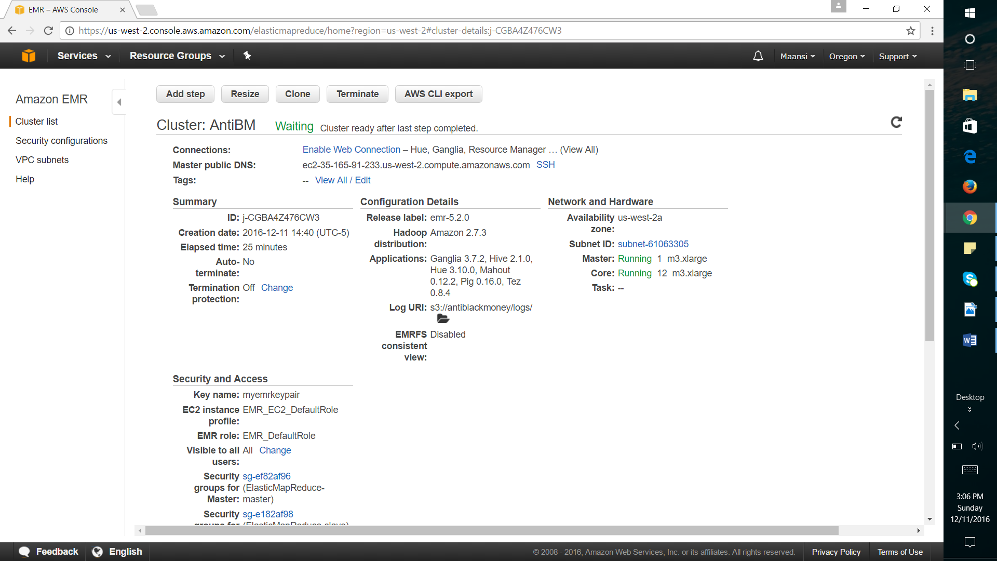

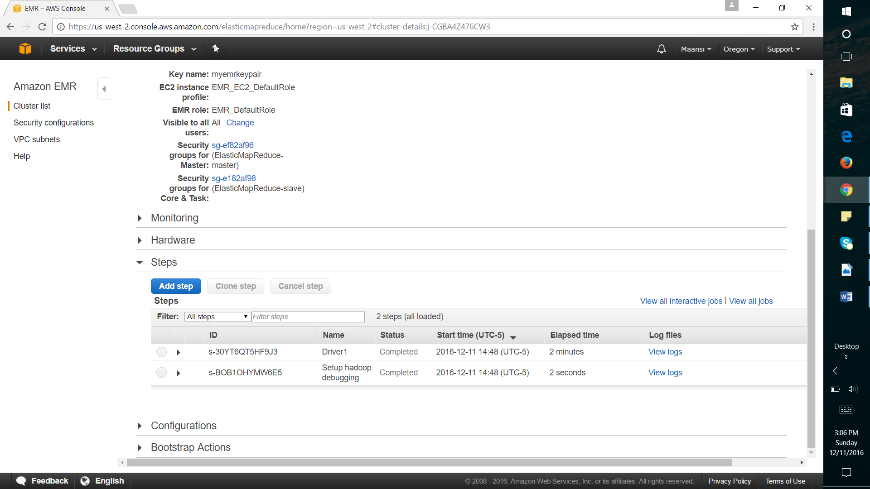

Three Jobs successfully completed

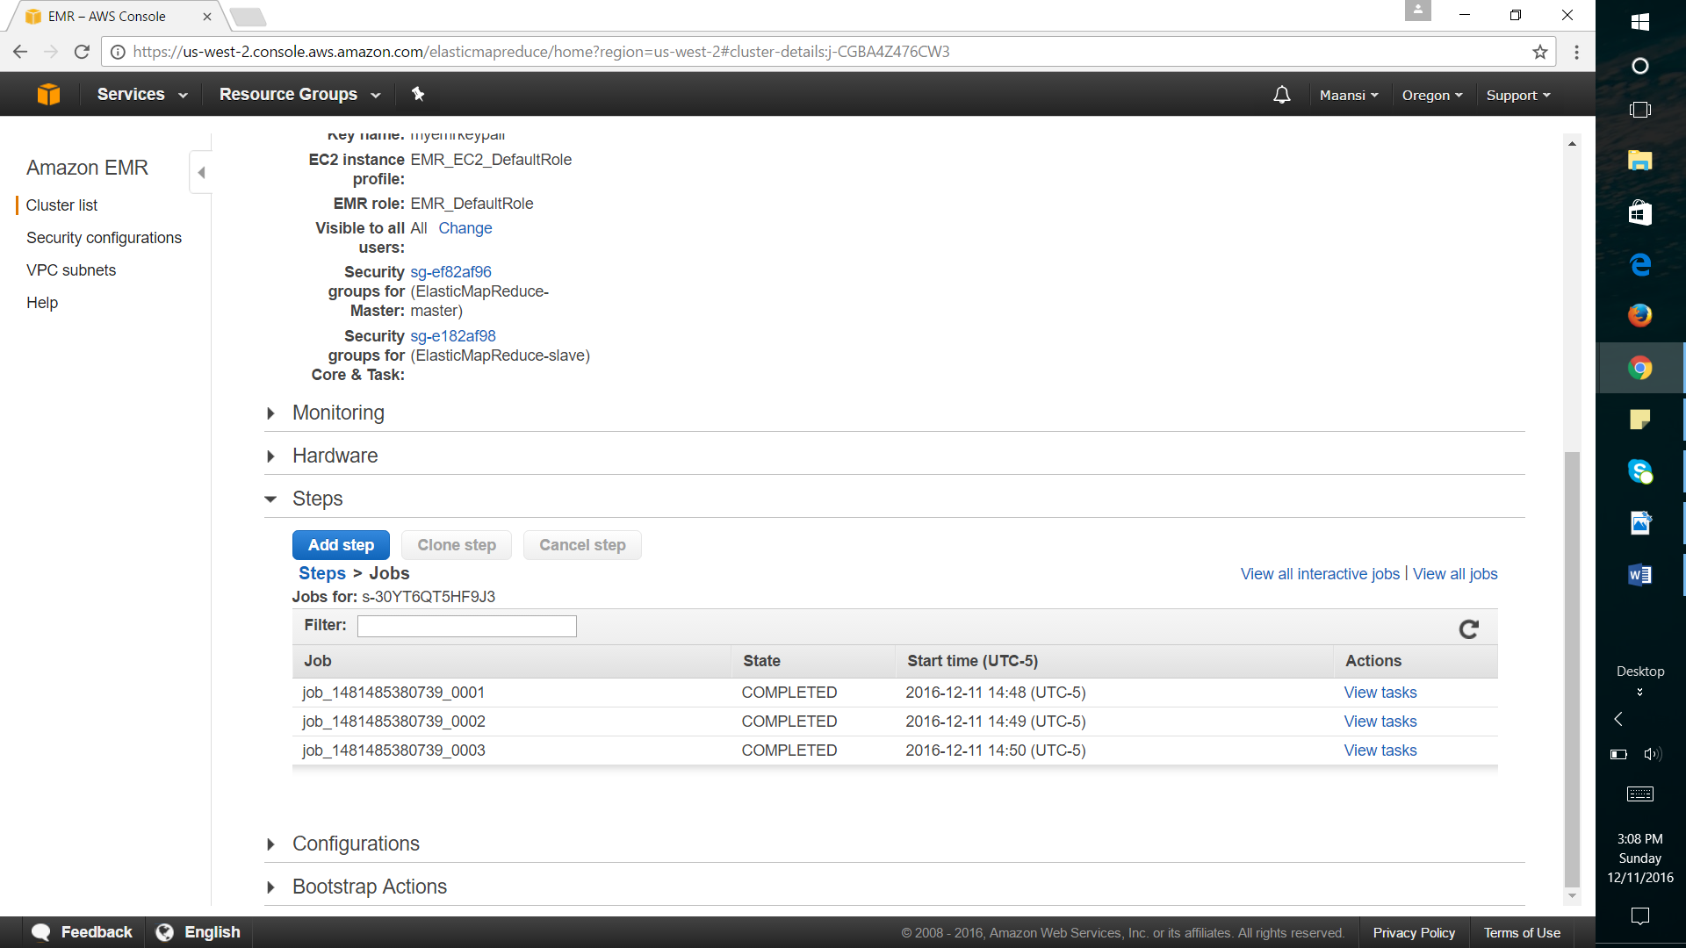

One Job tasks with count of total tasks

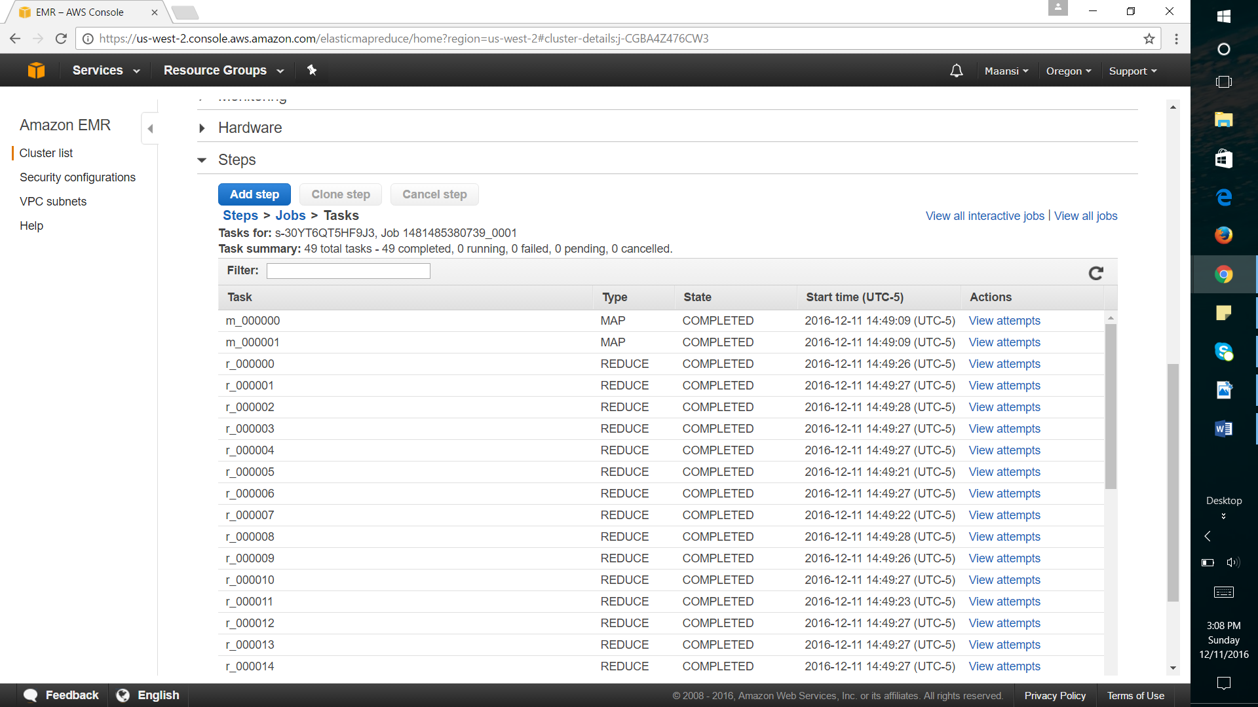

S3 Bucket list:

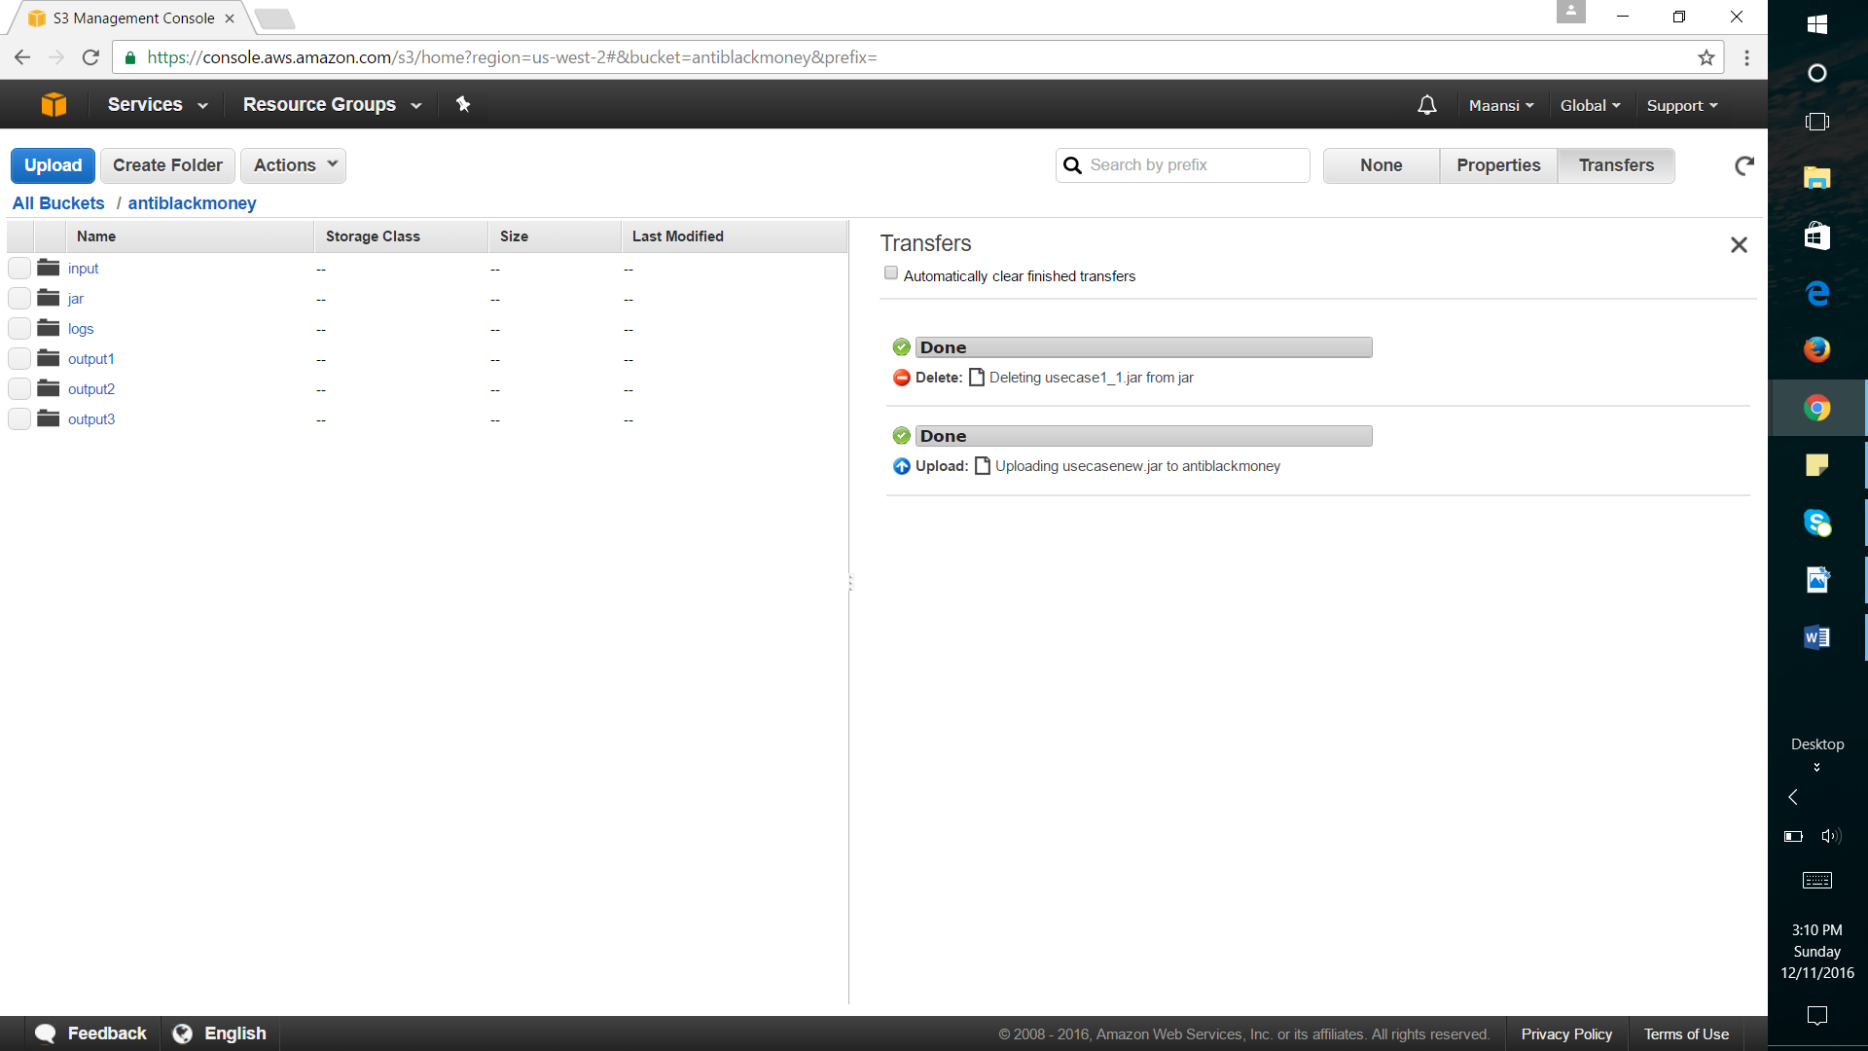

Logs:

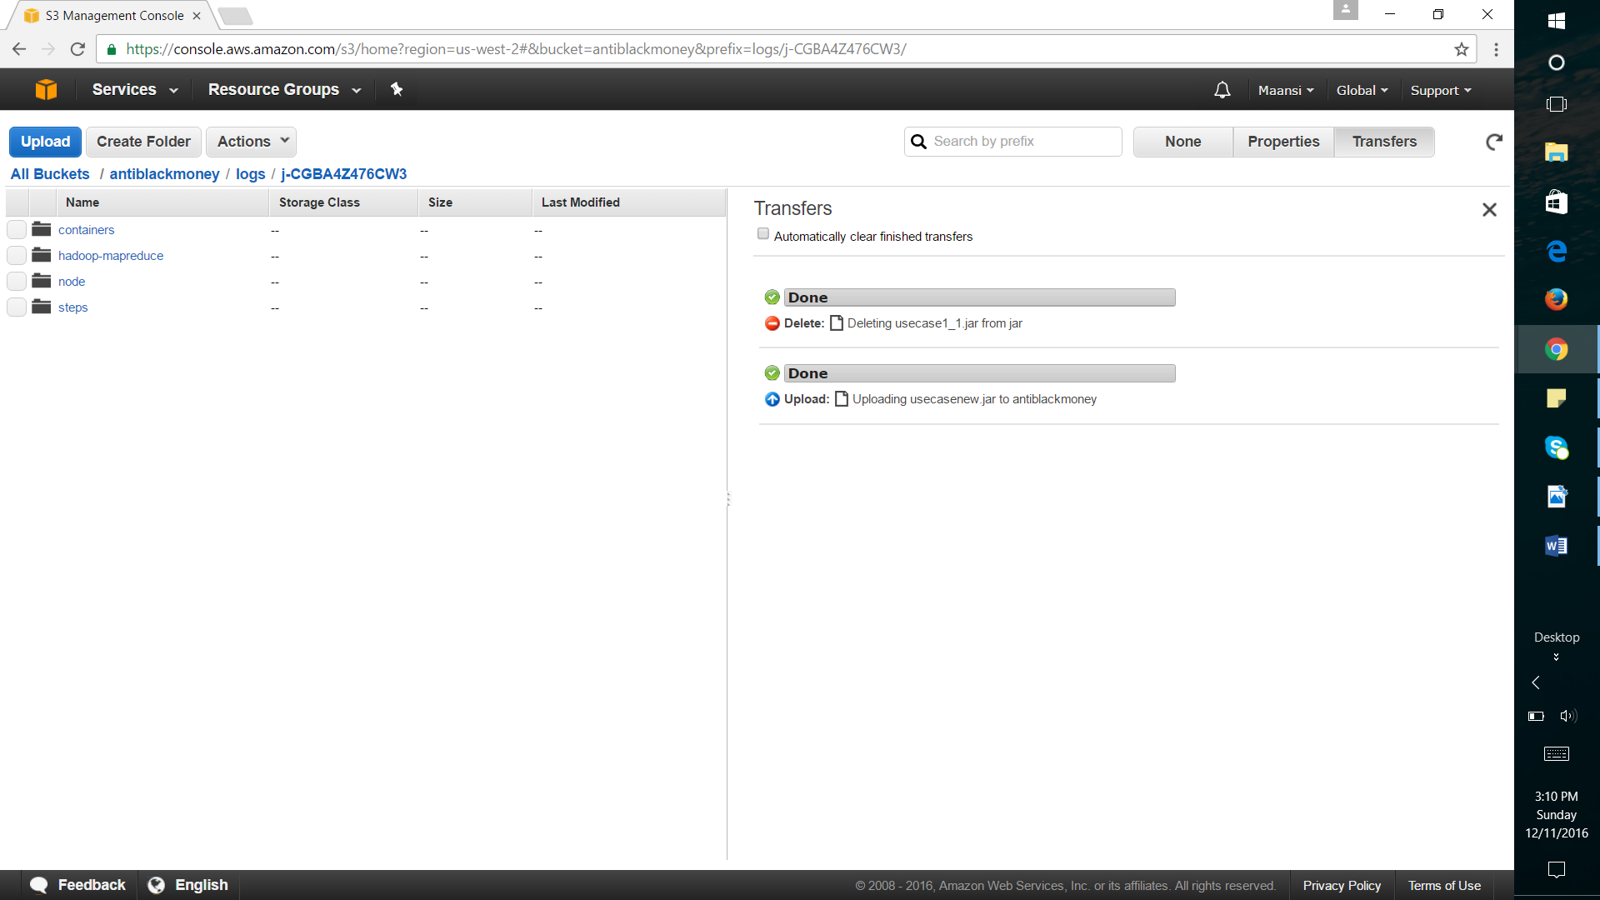

Output of first Job with Part details:

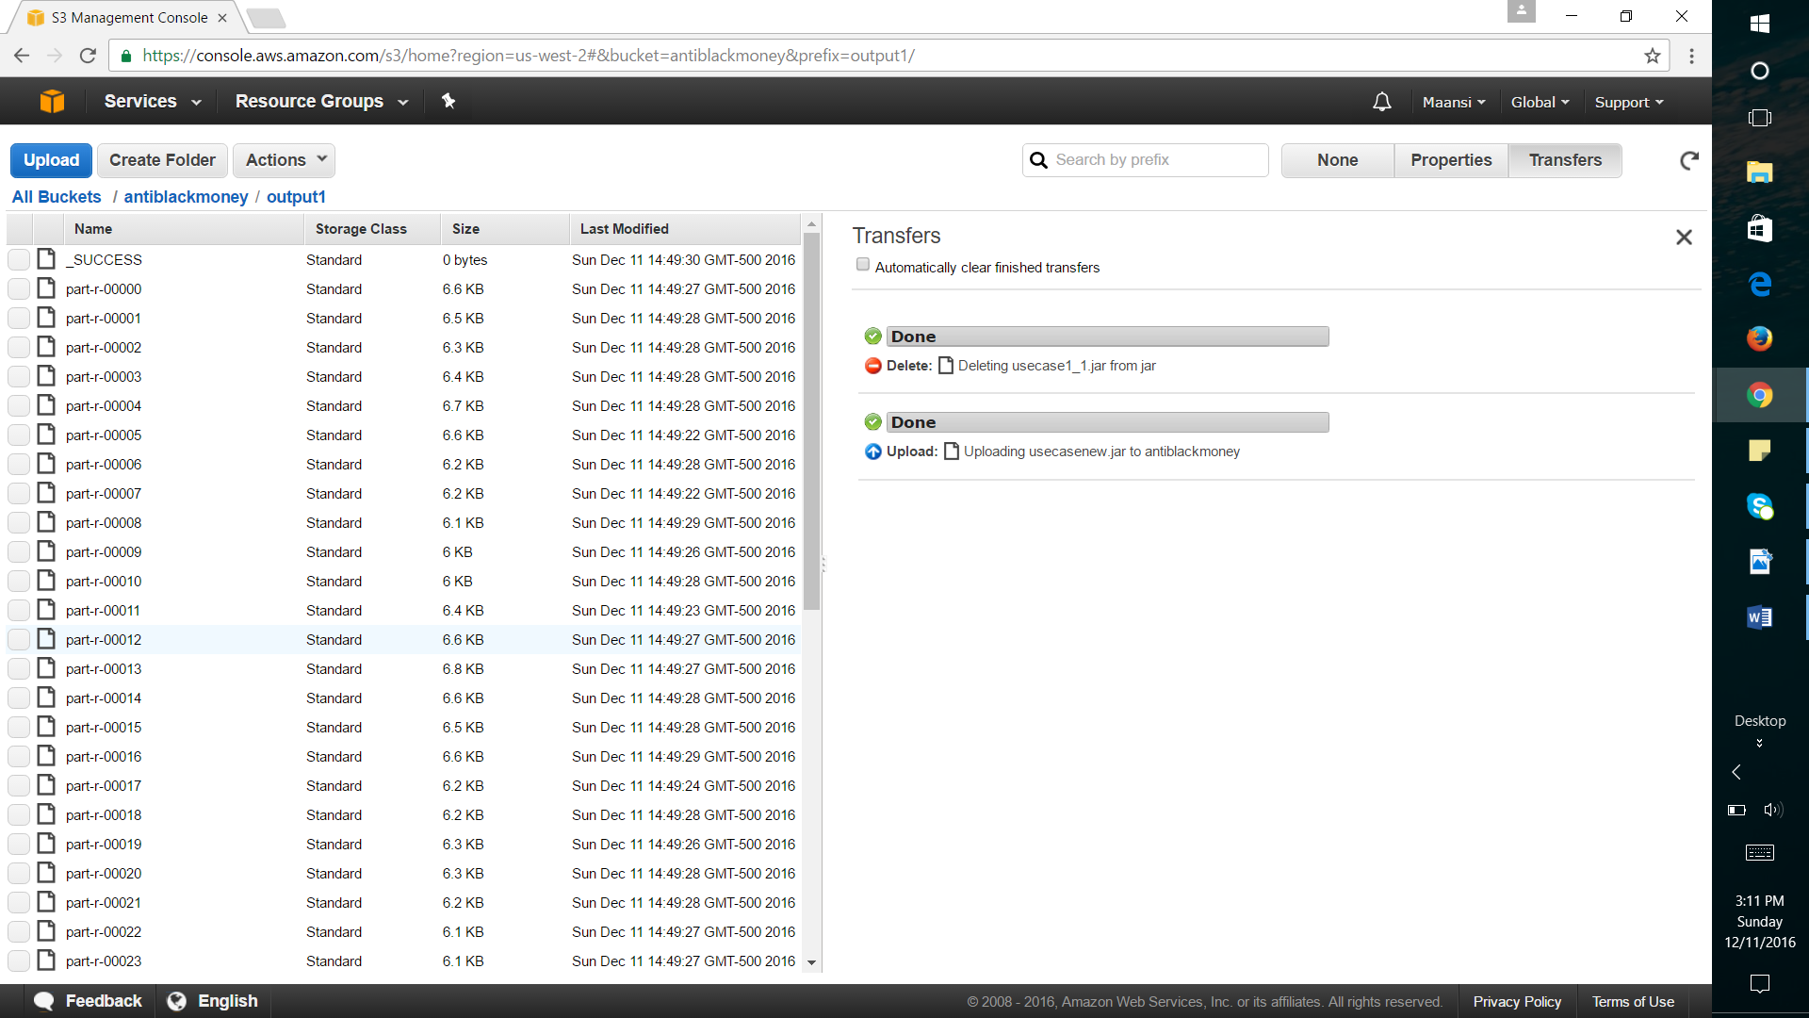

UseCase 2 Screenshots”

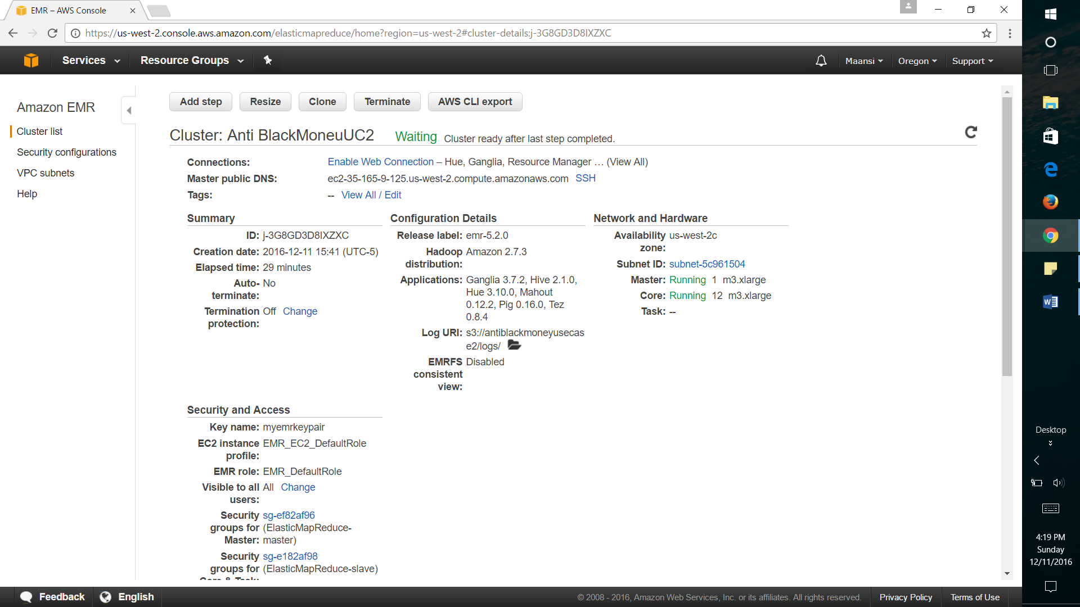

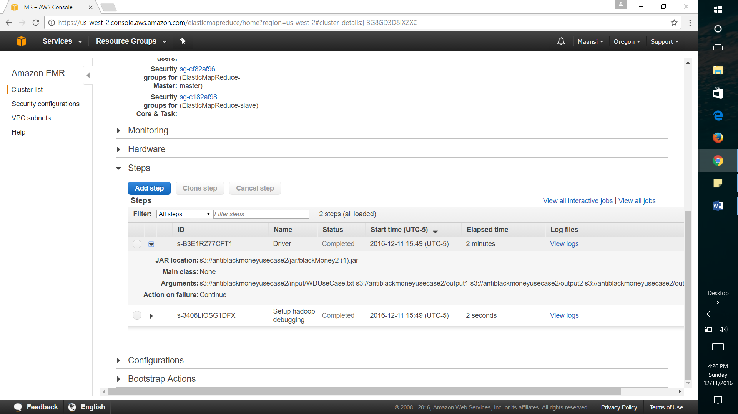

Three jobs successfully completed:

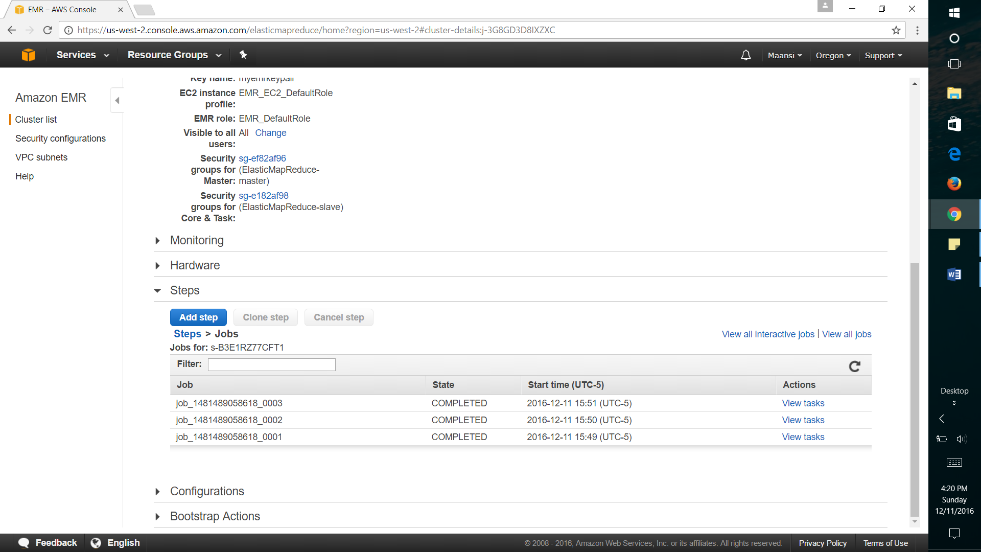

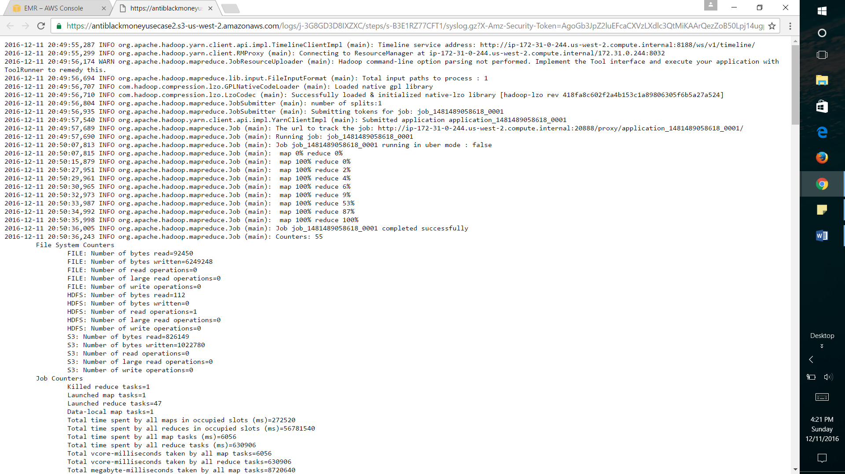

Job 3 with total count of tasks:

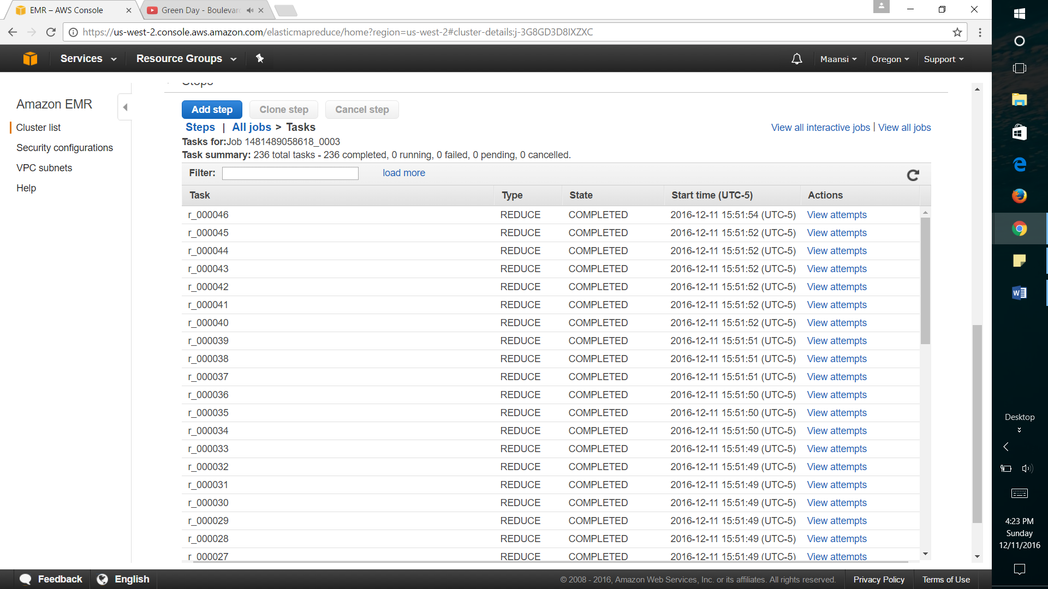

S3 Bucket for UseCase2:

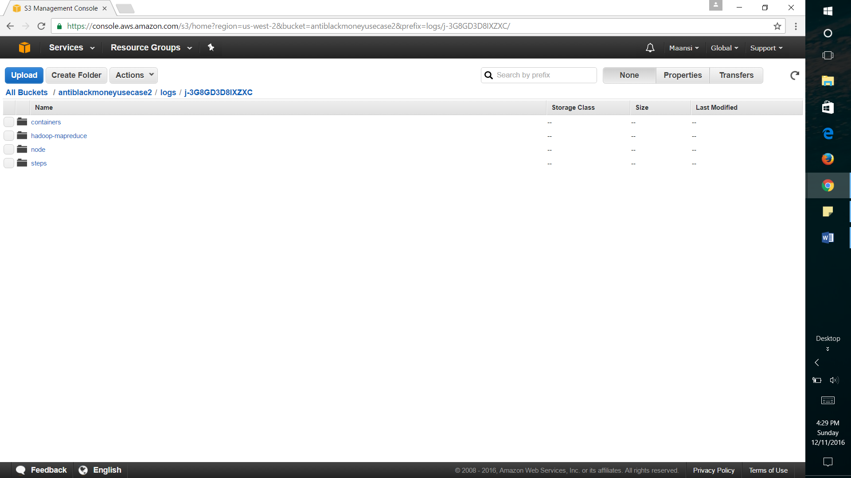

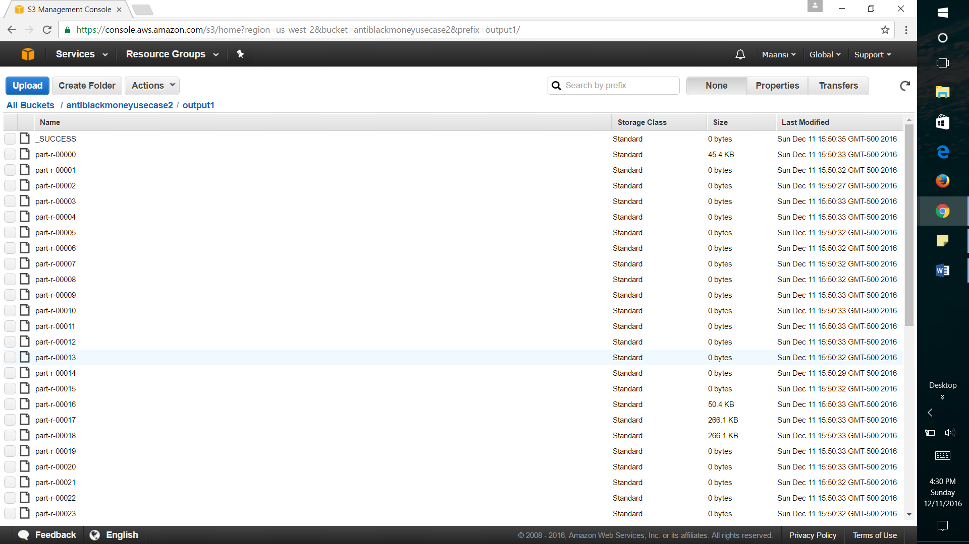

EMR – Elastic MapReduce provides a managed Hadoop framework that makes processing of vast amounts of data across dynamically scalable Amazon EC2 instances.

S3 – Simple Storage Service is a storage service with a simple web service interface to retrieve any amount of data from anywhere on the web.

With the help of both AWS services one can dynamically process huge data sets in a very efficient manner.

**Steps to execute AWS EMR with AWS S3:**

**# Create bucket, under bucket create folders, and upload all input files along with the jar having all compiled classes.**

**# In EMR, create clusters and configure total number of nodes (combination of master and slave)**

**# Configuration of HDFS and all other nodes has already been taken care of by AWS EMR**

**# At one stage we add a step with custom JAR and add related arguments with the path of input files and jar location**

**# That step creates jobs and each job internally runs multiple tasks (in combination of Map and Reduce)**

**# Life cycle of cluster operates at different stages and after successful execution it outputs log files along with output part files under one job flow with a status of Completed and a cluster status of Waiting after last step completed**

# R Visualization Report

1. Plotting BlackListed Money Holders Location

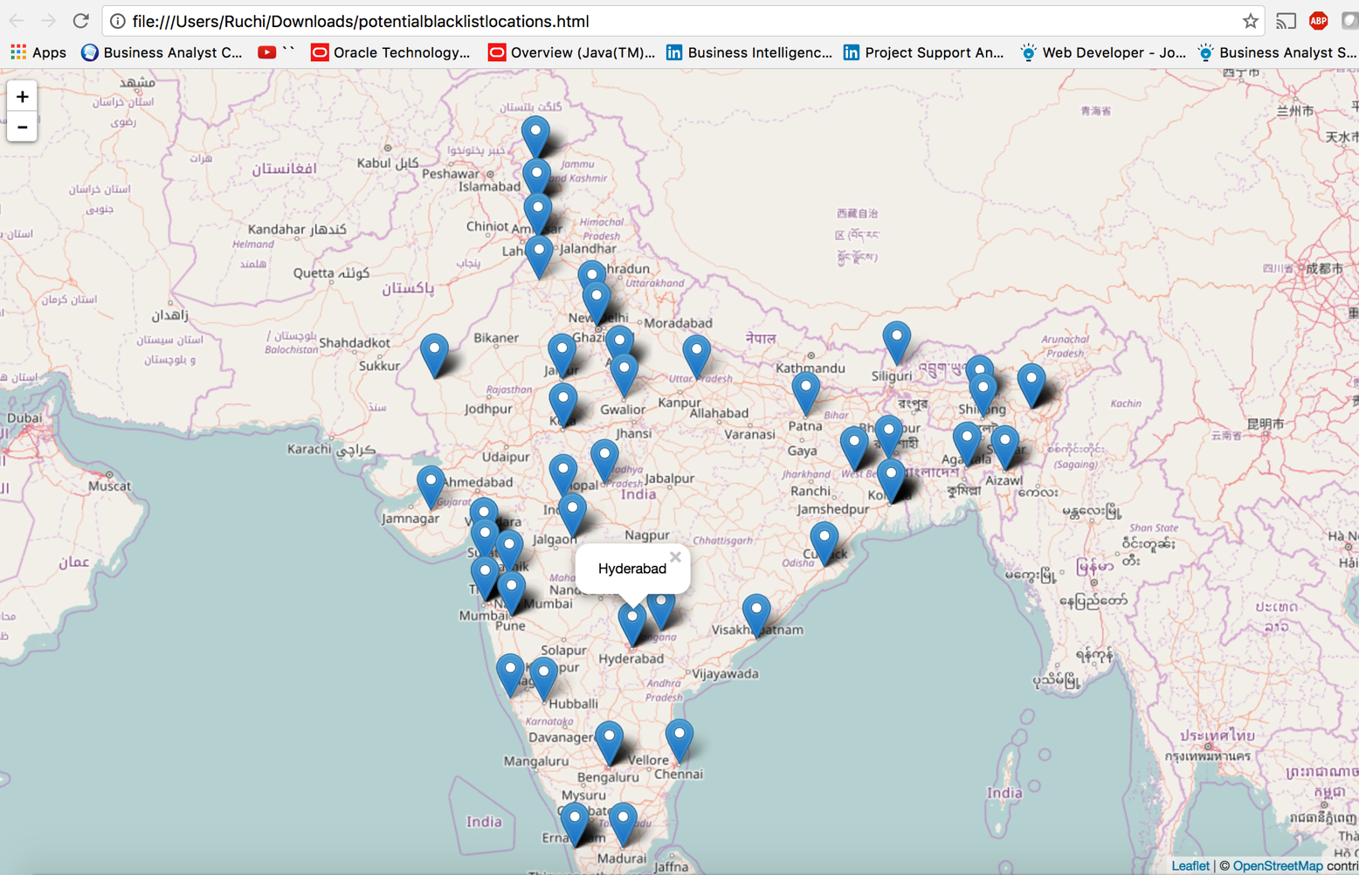**R Code**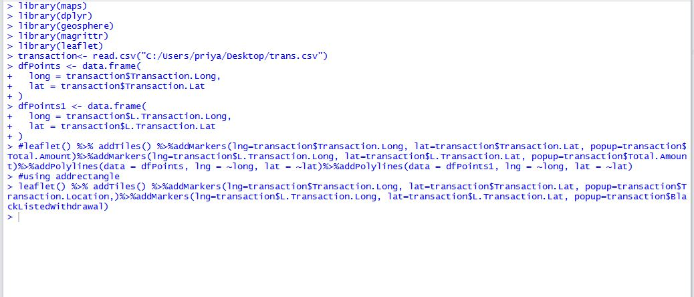

**Mapping the geo Location:**

The map is plotted in R and displayed using various libraries like maps, geosphere. In this map we are displaying the geographic locations of the blacklisted money holders

1. Use Case 2

**Network:**

The map is plotted in R and displayed using various libraries like igraph, network, sna, ndtv. In this map we are displaying the nodes as transaction account holders and edges as the link between the node. Every transaction is plotted on the graph and segregated using color. White transactions (No money hoarding) are given the color “Blue” whereas black transactions (transactions above 5 million and also above 70% of the total transactions notes which match the blacklisted notes) are given the color “Red”. The display is plotted on the browser. With additional features of displaying the ‘Pan Number and location’ on clicking the node and ‘Type of transaction (white or black) and amount’ on clicking the edges.

Code Snippet

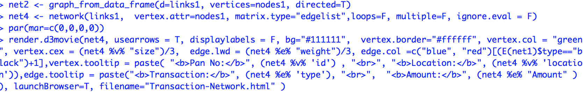

SCREEN SHOTS

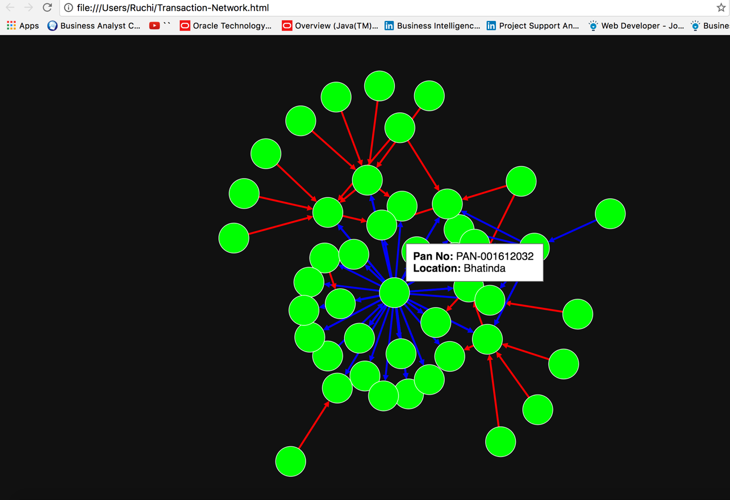

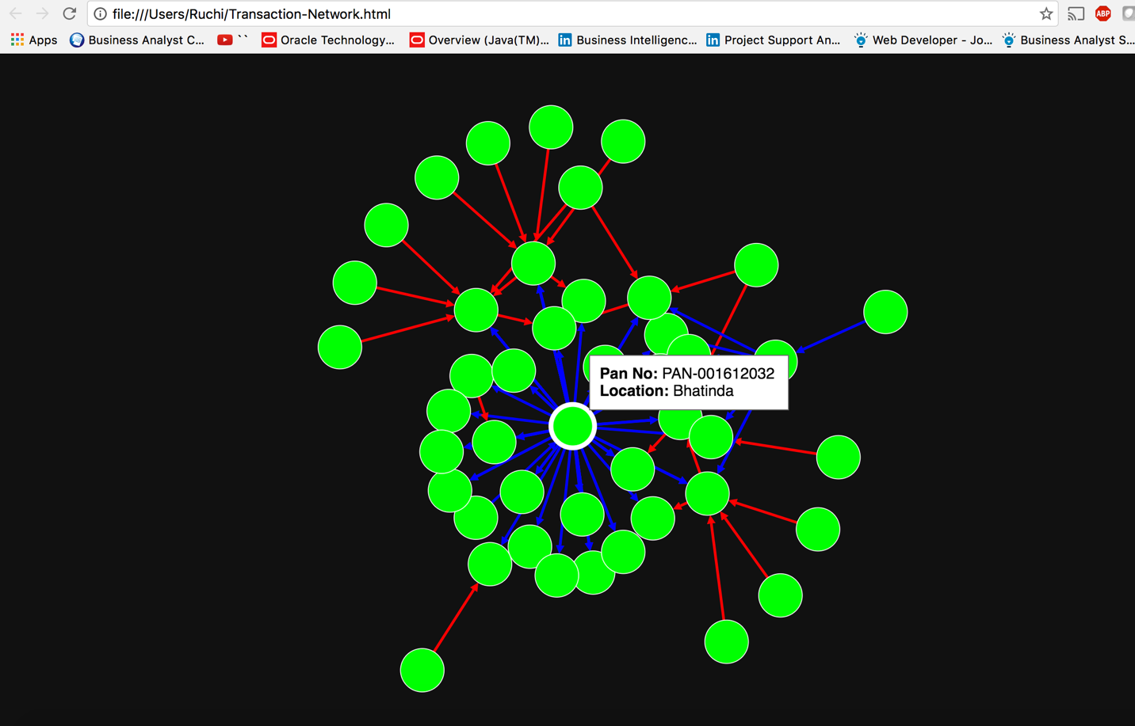

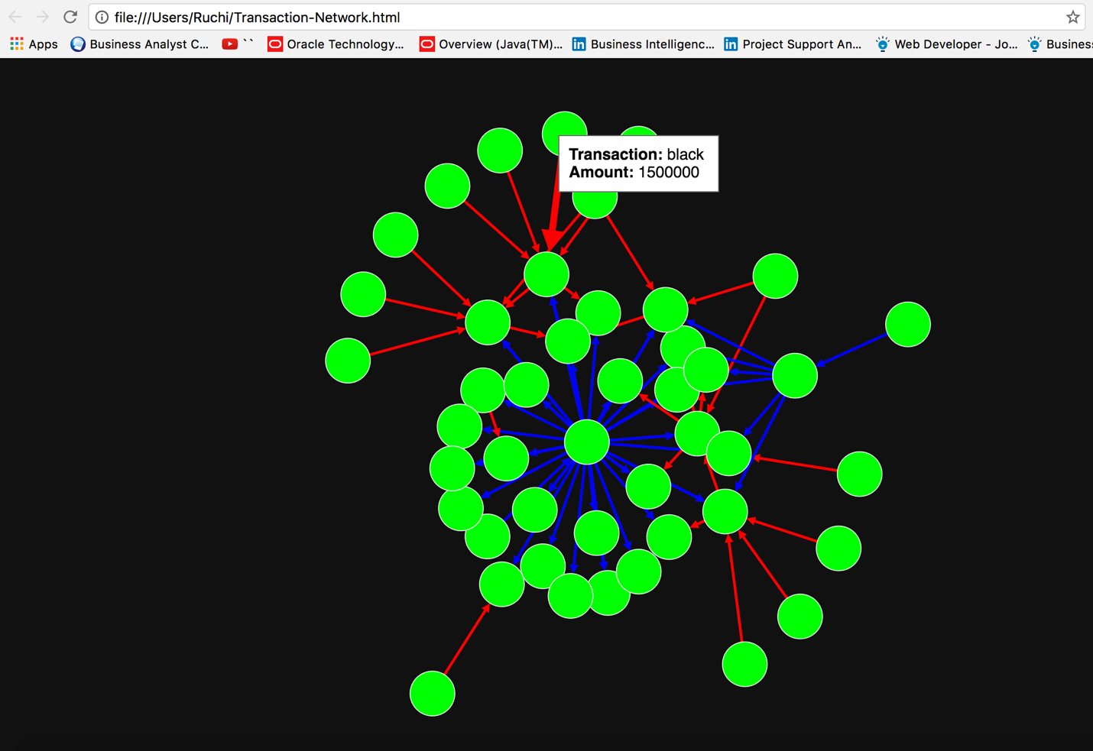

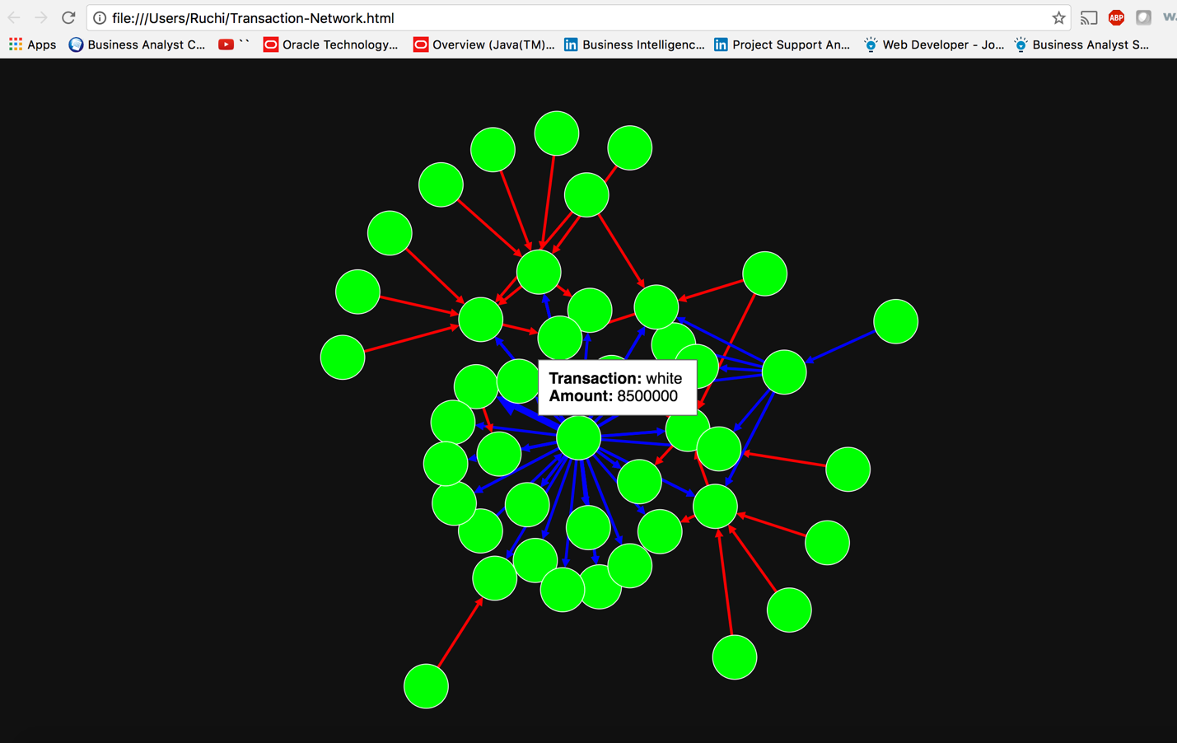

USE CASE 3: Plotting Page Rank with R

The map is plotted in R and displayed using various libraries like igraph, network, sna, ndtv. In this map we are displaying the nodes as transaction account holders and edges as the link between the node. Every node is Pan number(unique like SSN). The map-reduce calculates the page rank of every Pan number based on the number of transactions it was involved in.

Every node shows the Page Rank weight of the Pan No. Every transaction is plotted on the graph and segregated using color. White transactions (No money hoarding) are given the color “Blue” whereas black transactions (transactions above 0.5 million and also above 70% of the total transactions notes which match the blacklisted notes) are given the color “Red”. The display is plotted on the browser. With additional features of displaying the ‘Pan Number and location’ on clicking the node and ‘Type of transaction (white or black) and amount’ on clicking the edges.

Code Snippet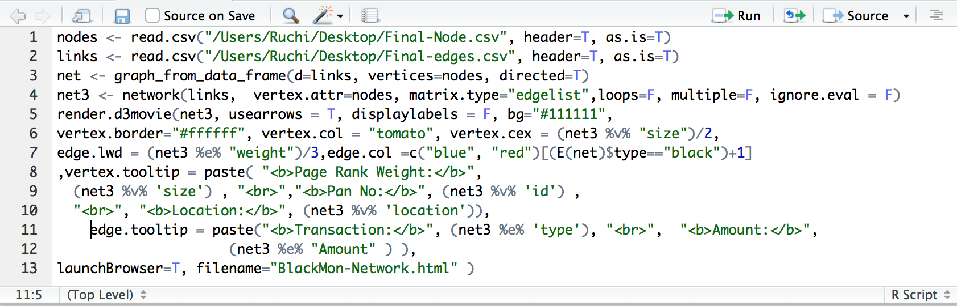

Screen Shot:

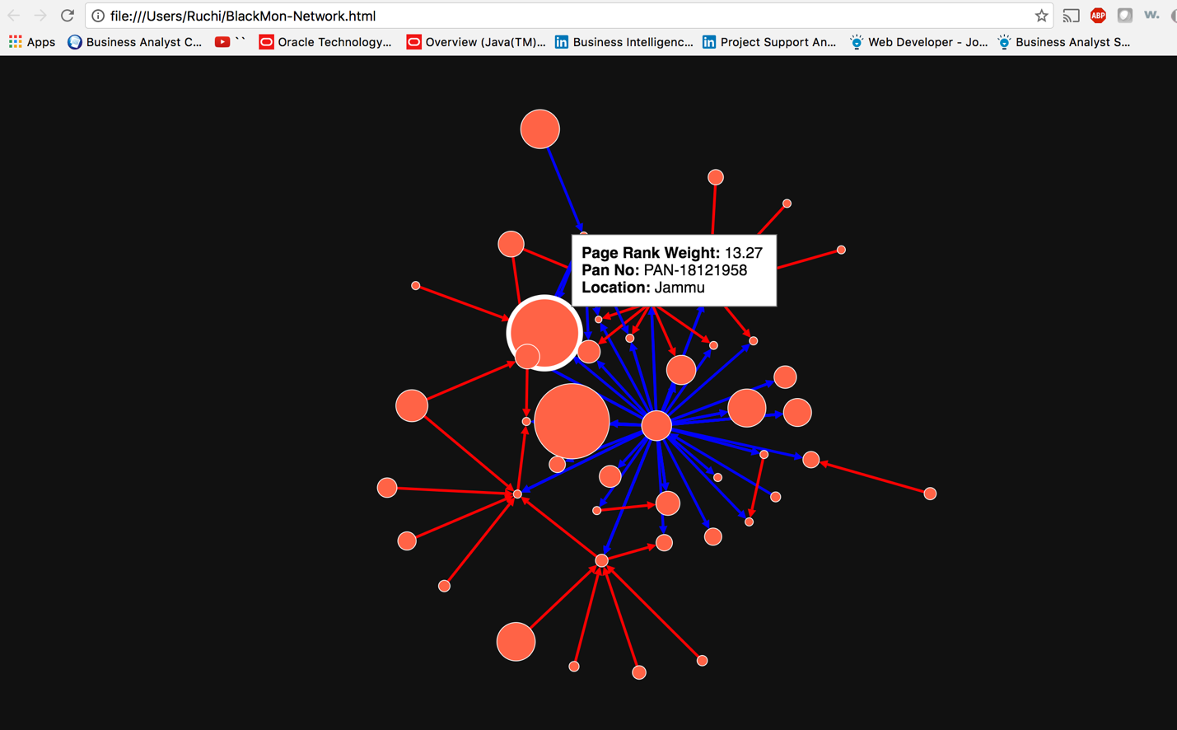

In this screen shot the highlighted node is involved in maximum transaction. The node represents the Pan Number which is unique. It also shows the Page Rank weight and location of the number associated with the location.

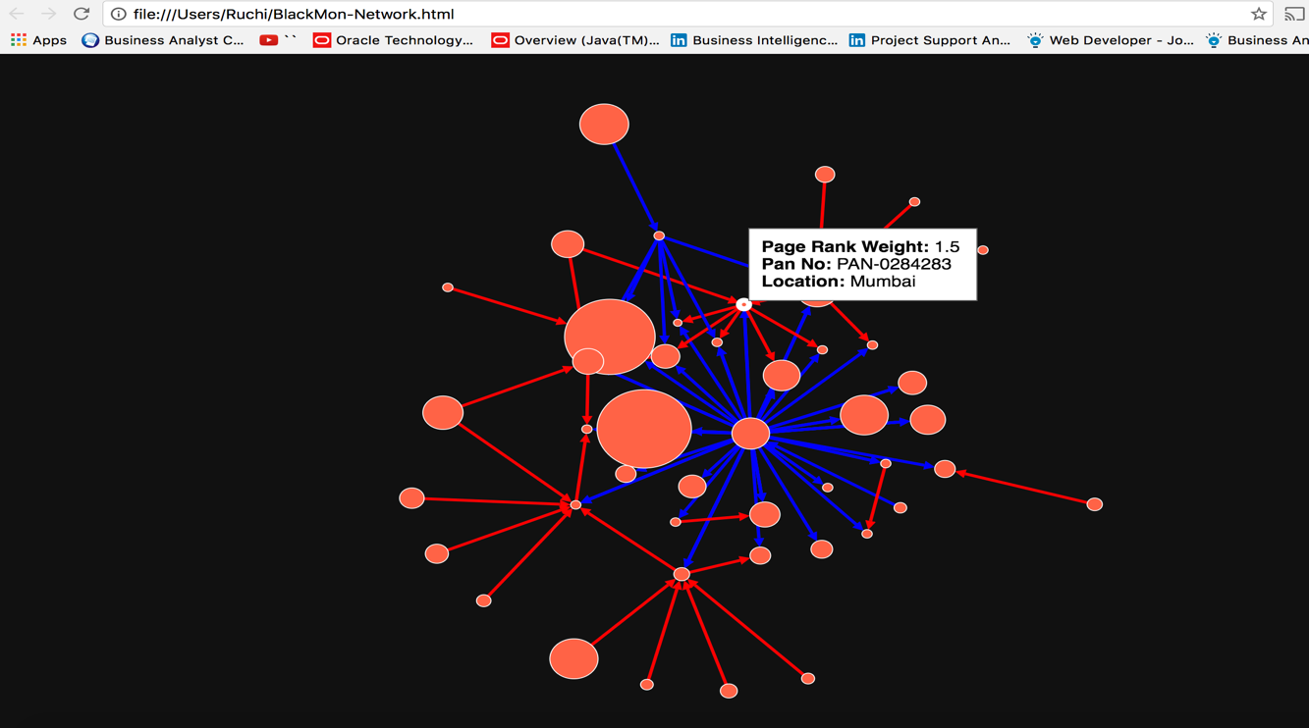

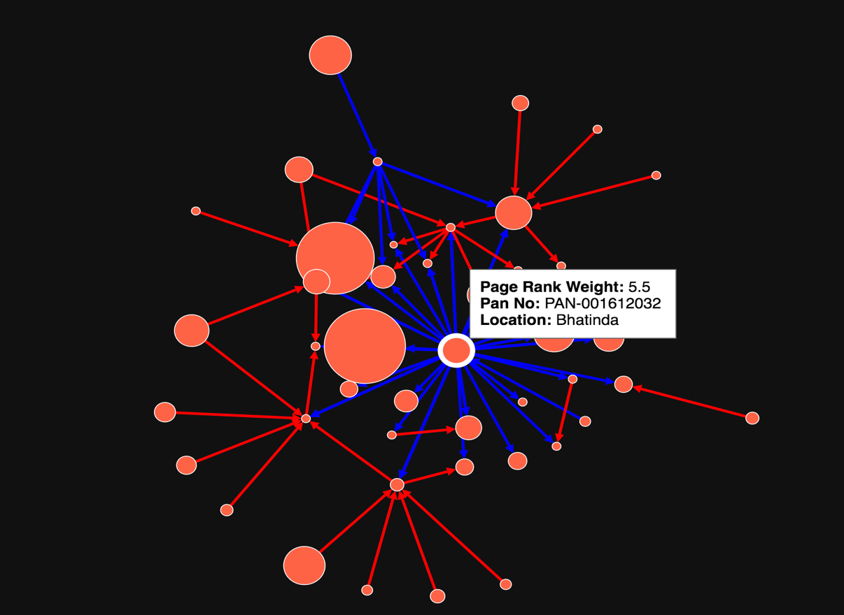

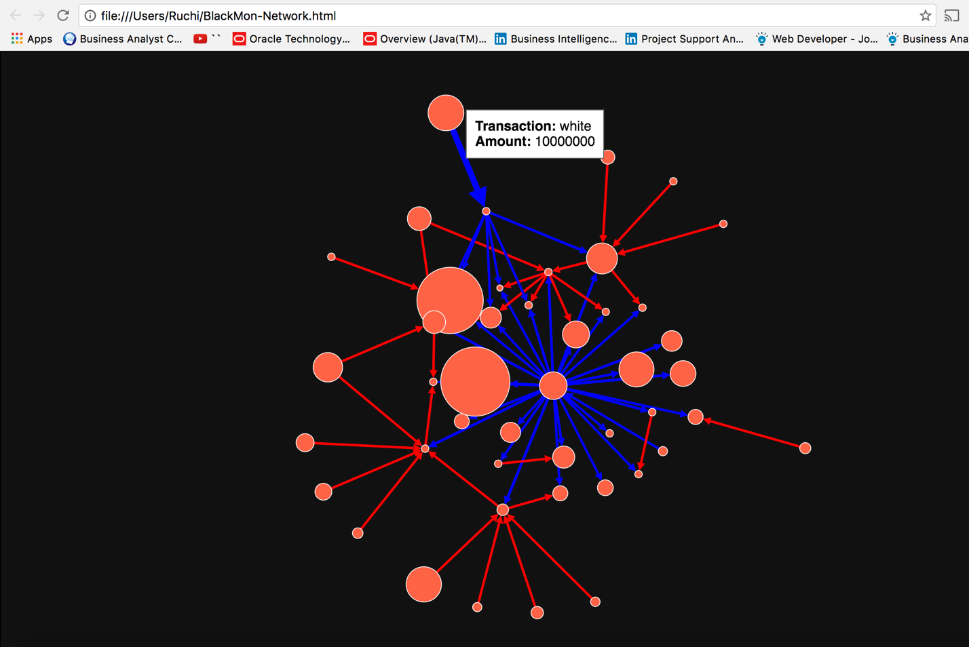

In the above image the highlighted blue line represents that the transaction was legitimate or white transaction along with the amount.

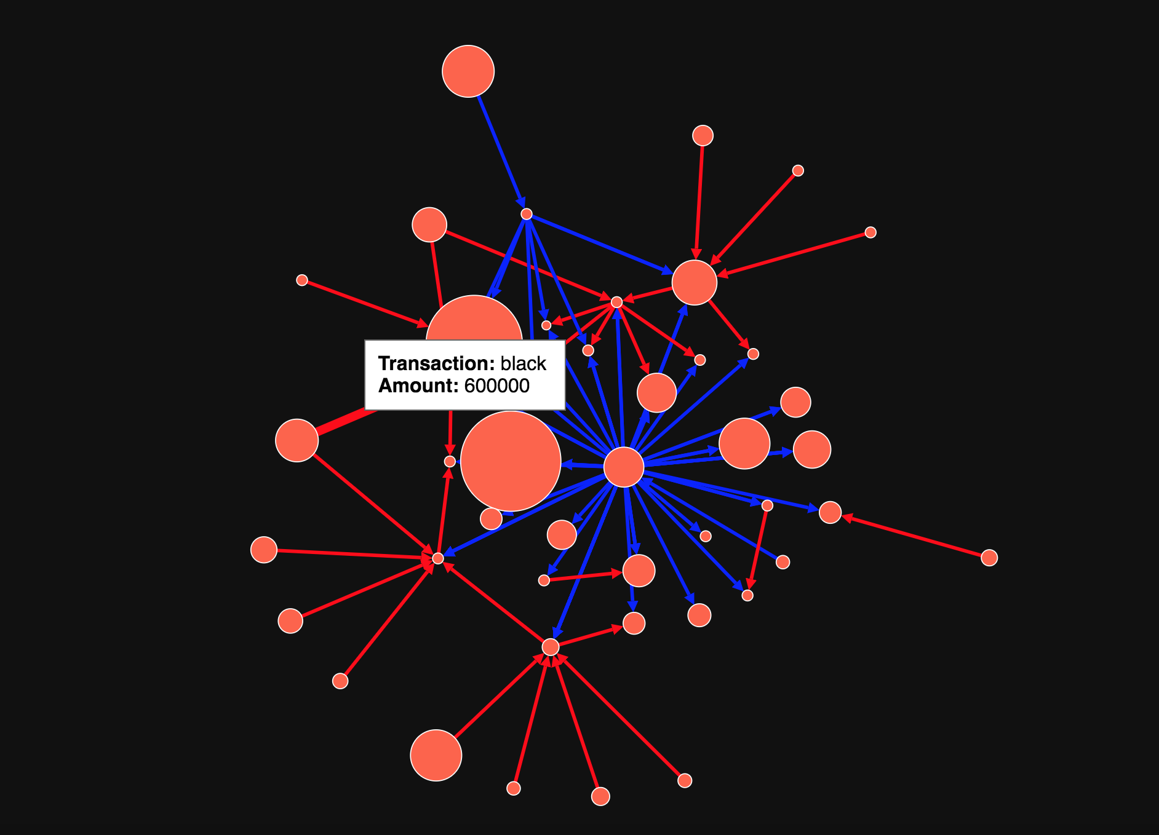

In the above image the highlighted red line represents that the transaction was black transaction along with the amount.